Hi Charlotte,
Following on from our conversation, I would like to put a request into the Parish Council to hold an event on the village recreation ground. The event would be organised by the Holt School Association raising important funds for Holt School.
The details are as follows:
Date: Saturday 3rd July 2027
Event title: Holt School Happy's Circus
Further details:
We are looking to hold a slightly different event next summer to raise money for the local school and would like to look at the options of holding this at the village recreation ground. A company called Happy's Circus is a family run company who travel the country delivering a circus show to help fundraising opportunities for school PTAs. This is the link to their website www.happyscircus.co.uk for more information on their history and to see further images of the set up and previous events.
The company was founded by Russ Randall in 1992. Happy’s Circus brings the enchanting world of Circus to schools, communities, and corporate clients across England and Wales. It is an all-human Circus with international artists, delivering traditional family entertainment in a contemporary style. Over three decades, the Circus has performed for millions of families, reawakening imaginations across Britain.
The company would arrive in the morning of 3rd July for set up, I can confirm this time with them if you require this information at this point. The circus show would start at 2pm with doors opening at 1.30pm. The show would finish at 4pm. To help raise more funds we would like to run a bar and BBQ prior to and for a short period after the event, which we would get the appropriate licences for.
The big top holds a capacity of 600 people which is fantastic as this would allow it to be an event for not only the children who attend the school and their families but for the wider community, for people of all ages. We anticipate that many of the people who would attend would be from the local community but appreciate that a number will be travelling by car into the village. We would look to put provisions in place for parking and marshalling this volume of cars on the day.
The company require a 50m x 50m flat grass area for their big top and vehicles. The vehicles require a minimum height requirement of 3.7m and a width of 3.1m. Does the access to the recreation ground allow for this?
This is an image of their set up on the day and the vehicle type:
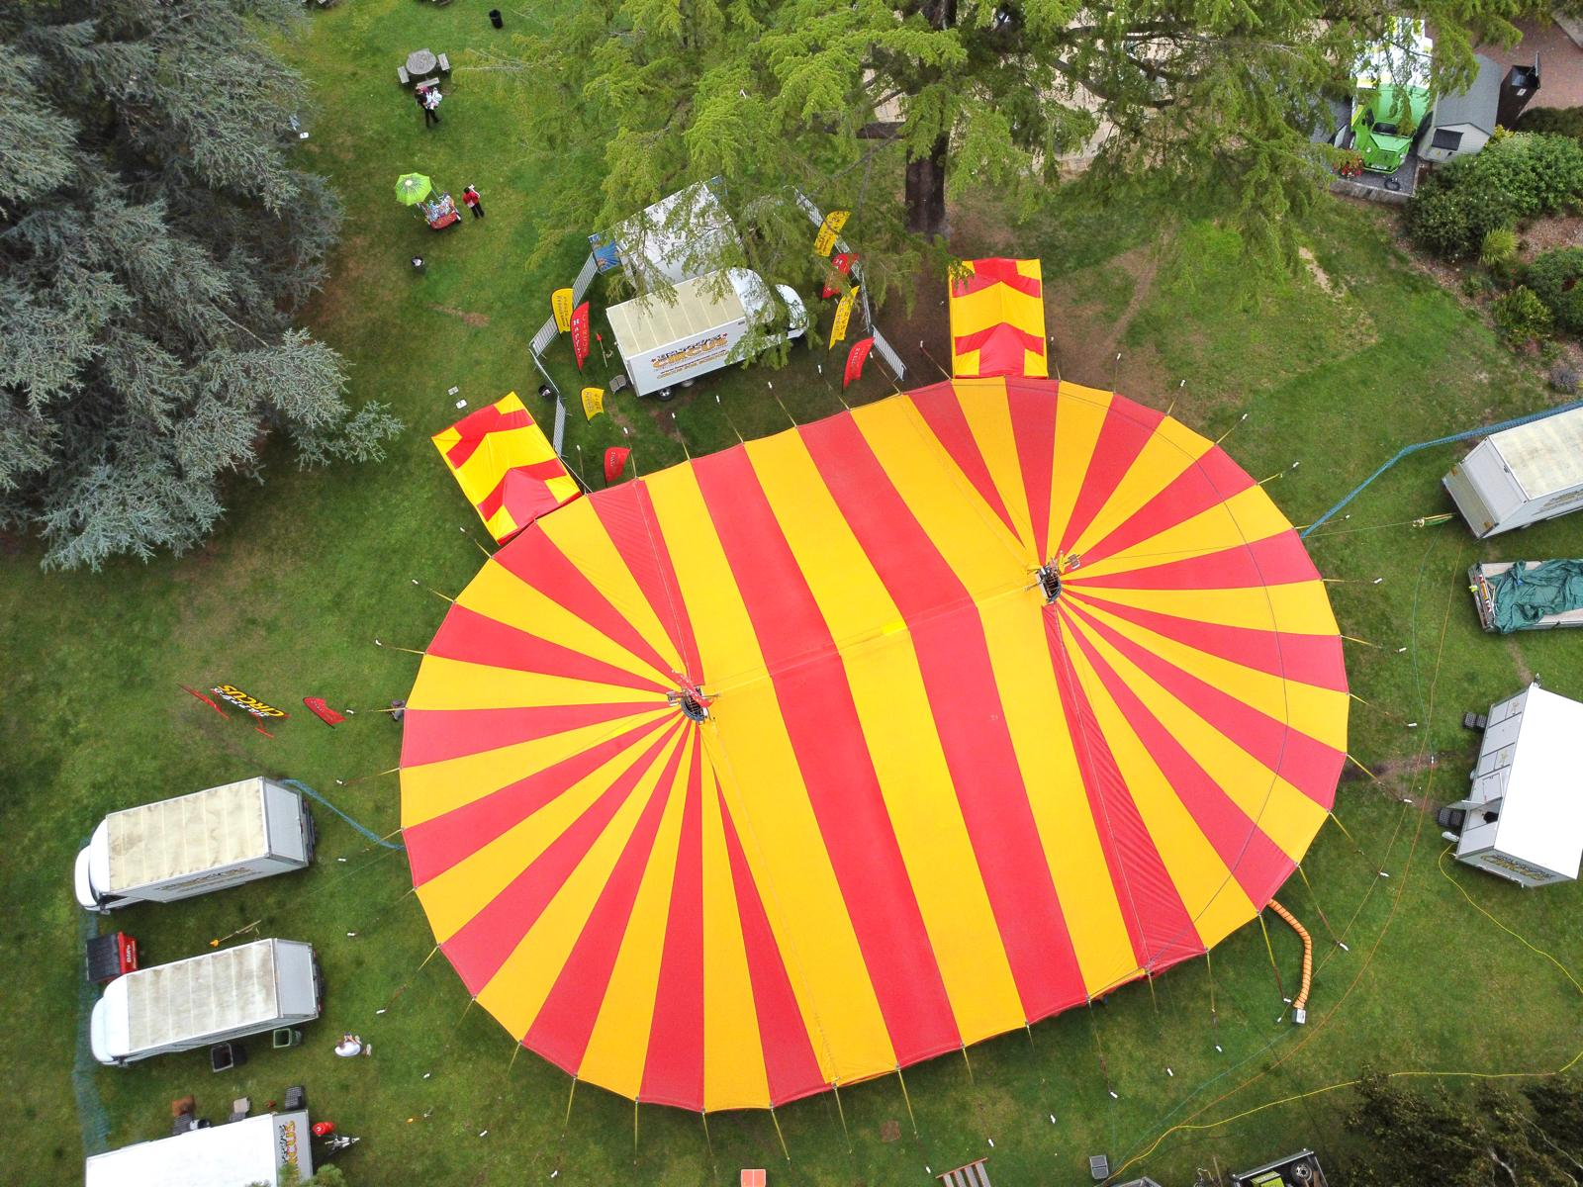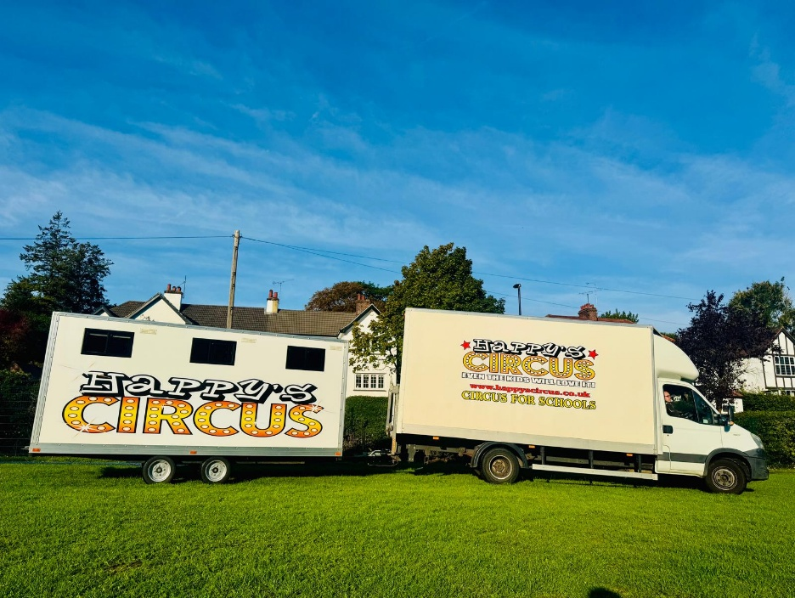
The company require a place to stay overnight after the show before they travel to the next event, however, I understand that this may not be an option in this space. This is not a problem as we can look at alternative options locally for them to stay.
We have looked at holding the event in the school grounds but unfortunately the space is too narrow. We also think it would be beneficial to be in a communal space at such a great central location within the village to open it to the wider community.
If you require any further information at this time, don't hesitate to let me know or if you would like me to attend the Parish council meeting to answer any questions then I am happy to do so.
Kind regards
Kat (Chair of HSA)

