Monthly Village Inspection Report
Please try and inspect as much of the village as you can
Month/year October 2026 By Cllr. Bertholle
Parish Council responsibility
AREA | OK | X | ? | COMMENTS
Other Greens:  Grass cutting, footways –  Litter - | OK
Little Parks  Grass cutting, path, litter | OK
Ham Green:  Grass cutting, path, litter – War Memorial |  | X |  | Traffic cone left on green  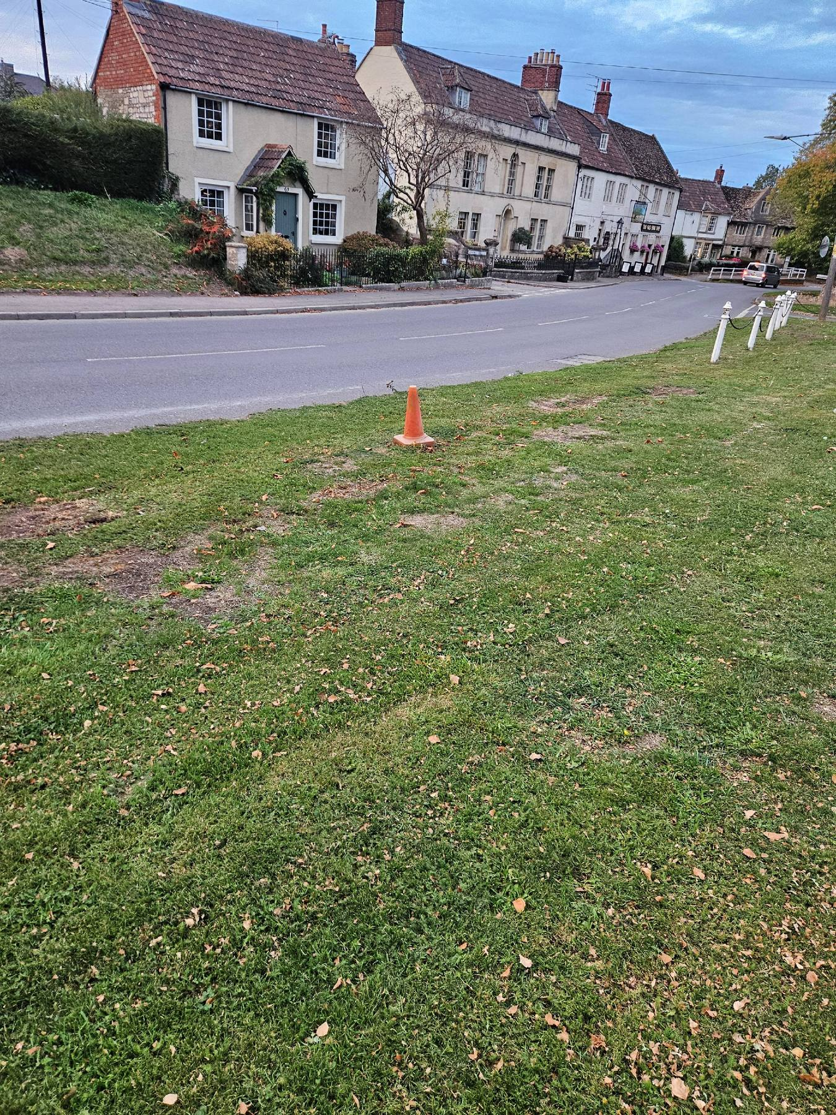  Wooden post next to bollard; with screws sticking out from the top end.  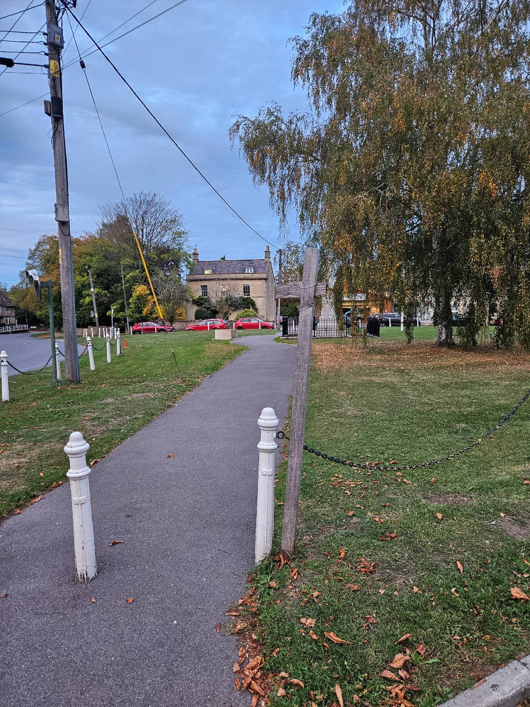
Footpaths | OK
Pavilion – general upkeep | OK
Play Area litter,grass,,any obvious safety issues | OK
Recreation Ground:  Litter, grass cutting, hedges | OK
Sports Courts: Only smaller of the 3 courts is PC owned  Litter /weeds | OK
Dawes Pond:  To include PC stretch of brook from Glove Factory to first “garage bridge” - |  | X |  | Overgrown vegetation in Brook at Dawes Pond  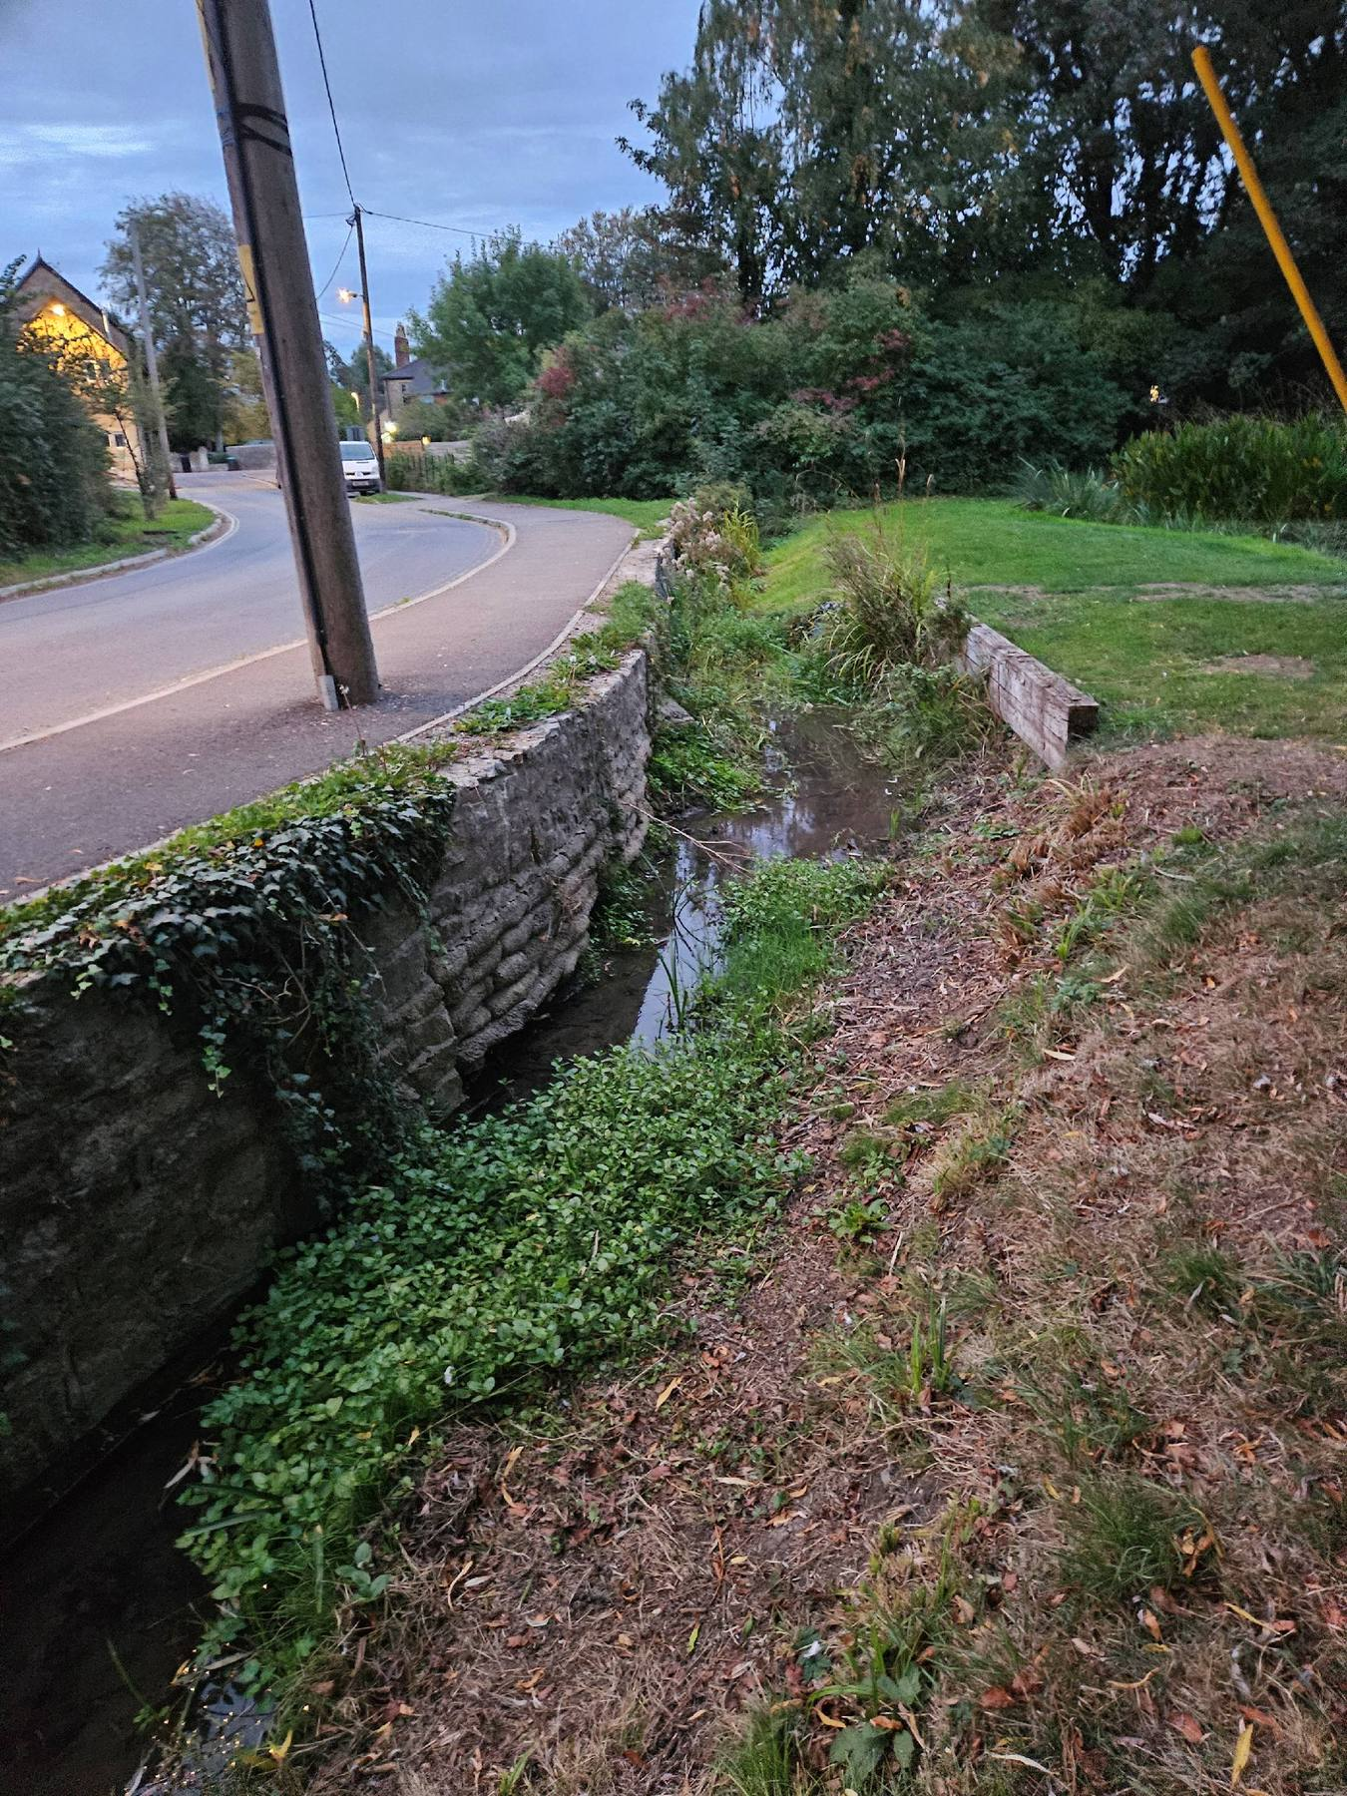

Wiltshire Council responsibility
General Litter: | OK |  |  | The village appears to be clear of any significant rubbish.
Village Signs: |  | X |  | Melksham/Broughton Gifford road sign (West end of Village) showing signs of damage  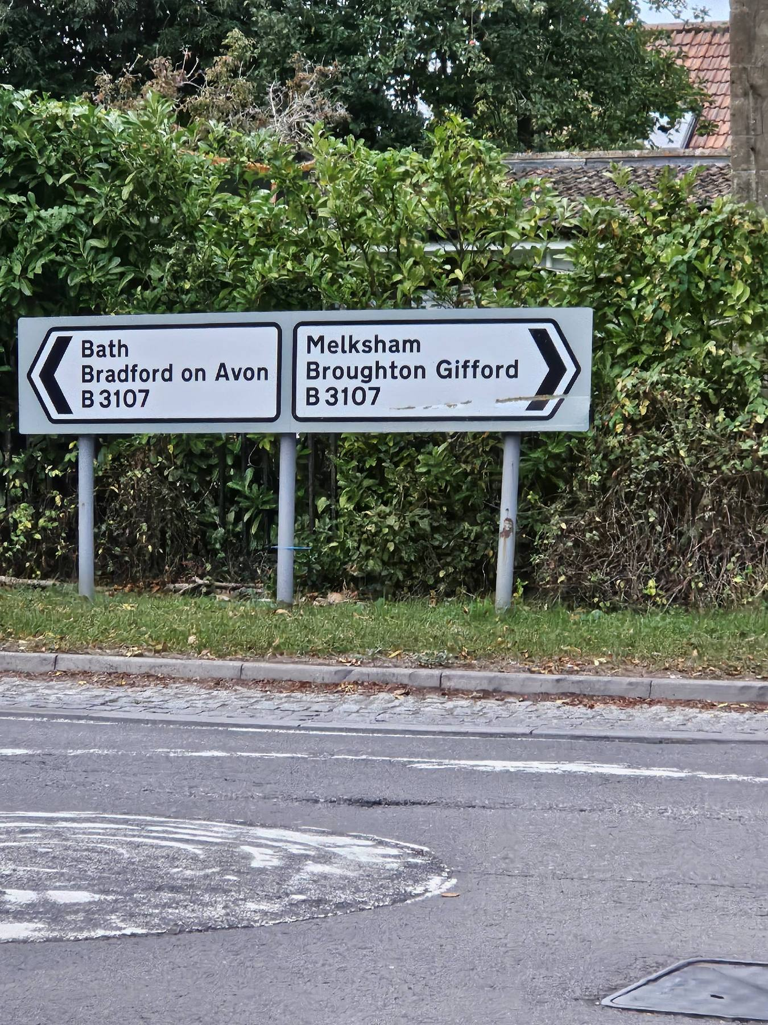
The Walk |  | X |  | Edges of the path are full of weeds and leaves.  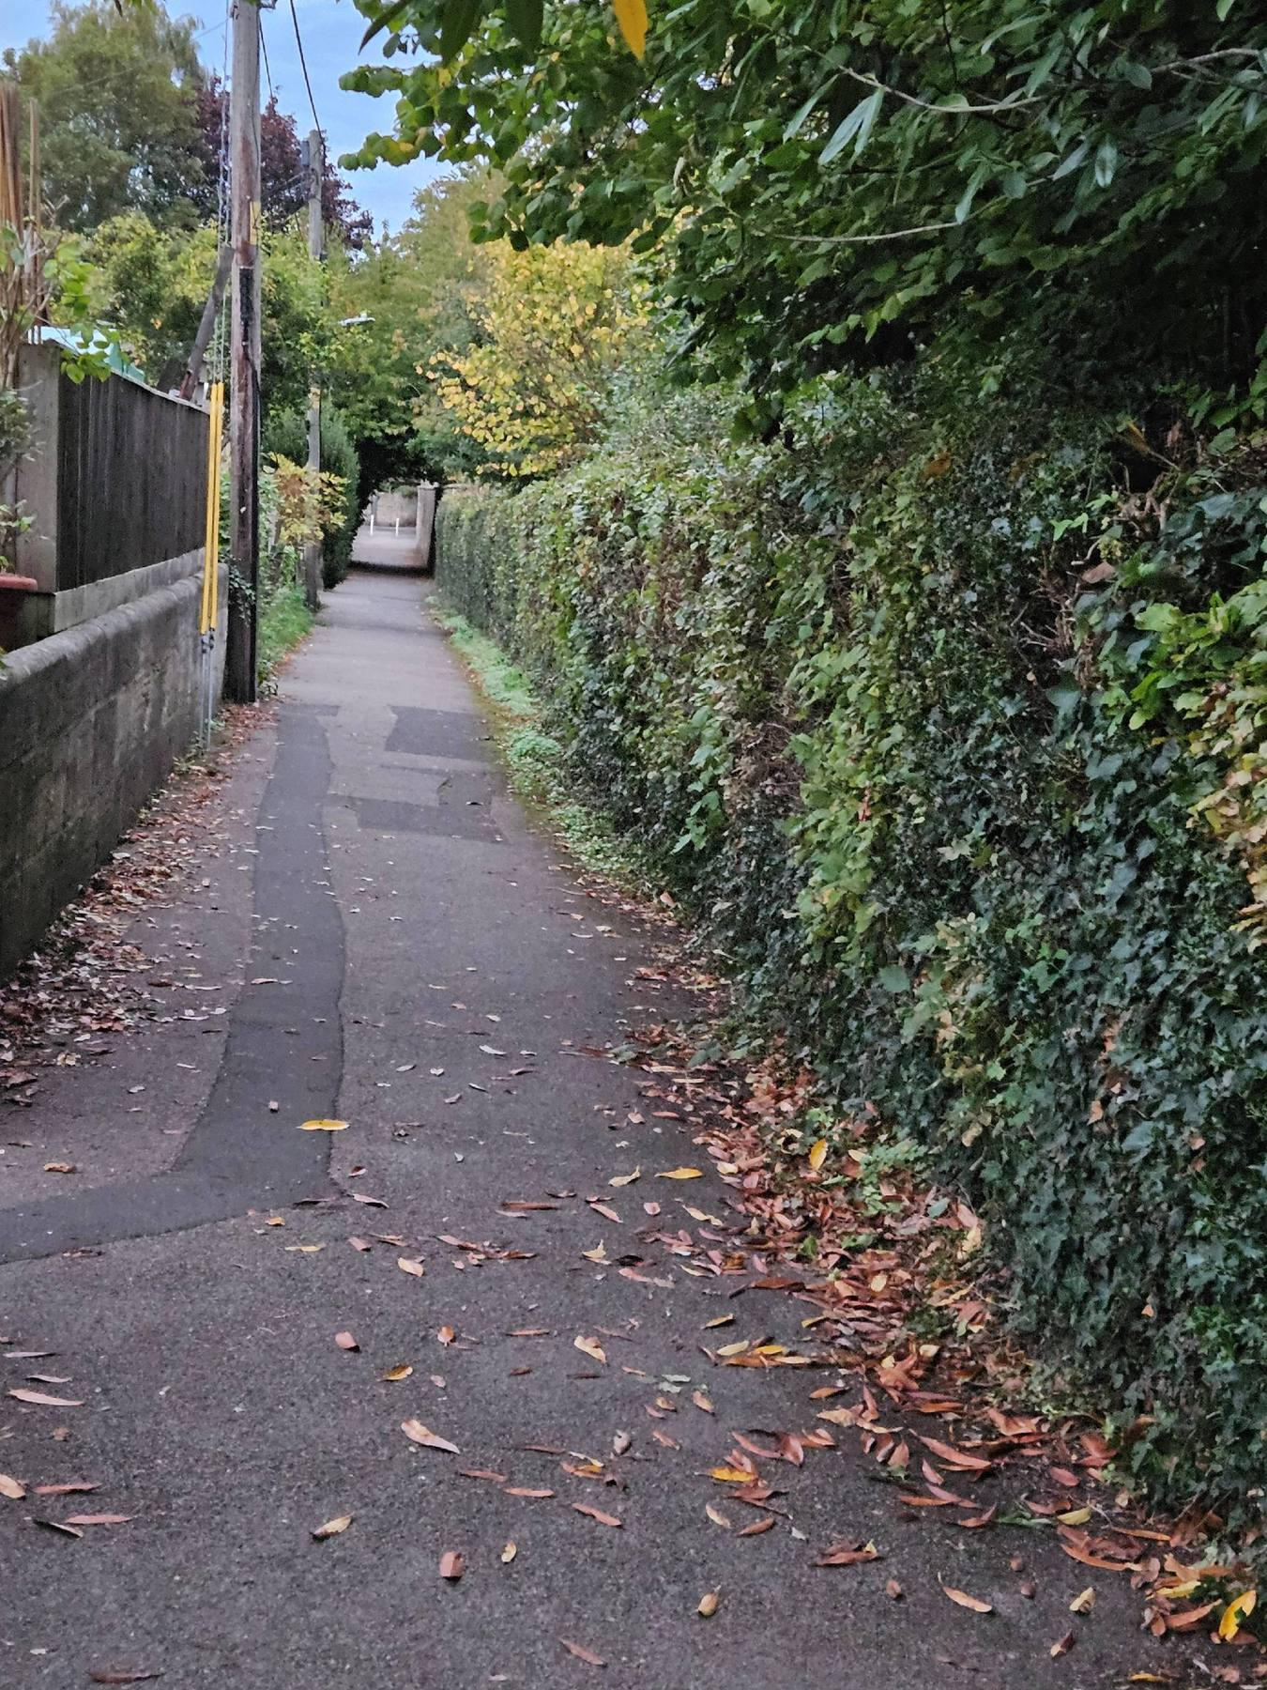  Water drain blockage caused by leaves  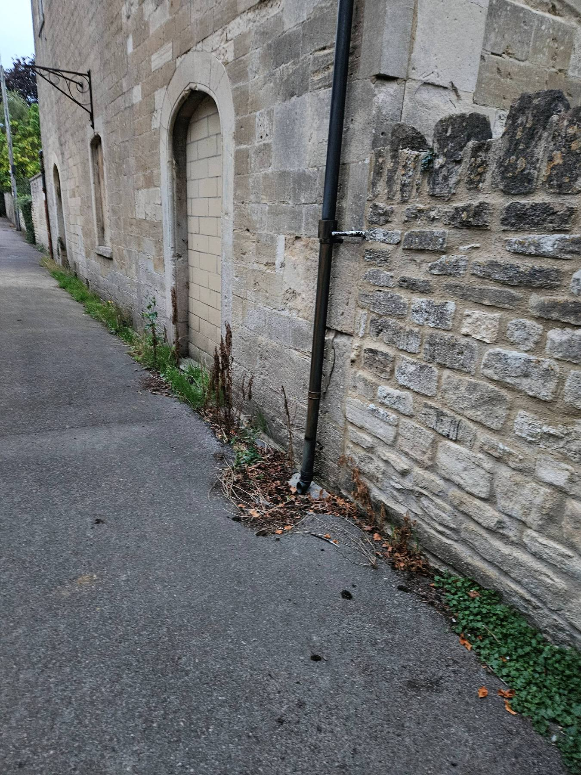
The Midlands | OK
Shop Area: | OK
Around St Katherines Church  General -  Litter /weeds |  | X |  | Weeds and leaves accumulating next to the pavement opposite Gaston farm  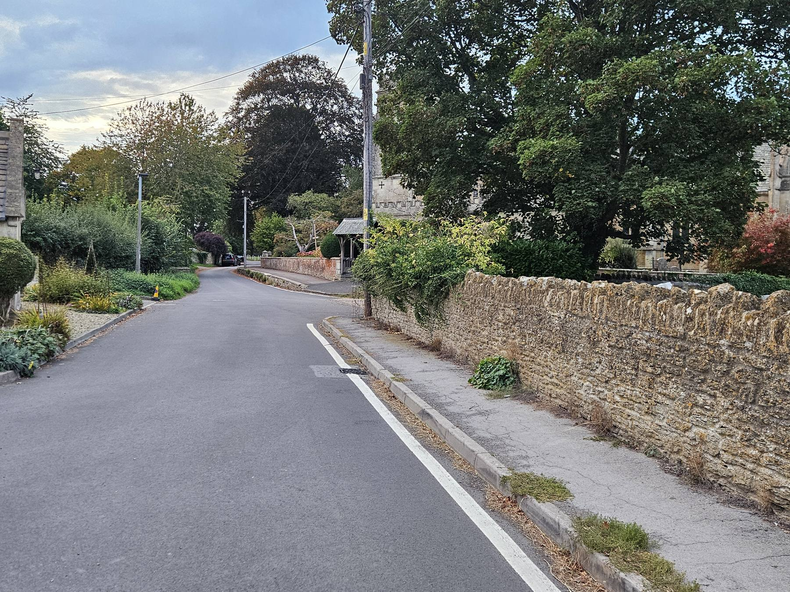
Pavements |  | X |  | Pavements and gutters throughout the village need to be cleared of leaves.  As an example, see photos of pavement and gutter below. The leaves hamper the flow of rainwater.  Leigh road by the Tollgate:  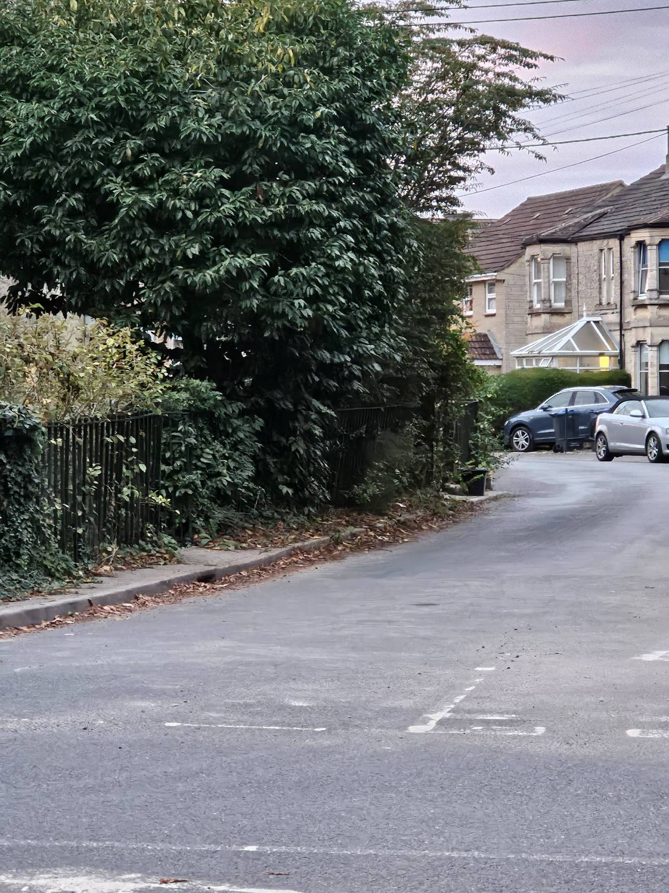  West end of The Street:  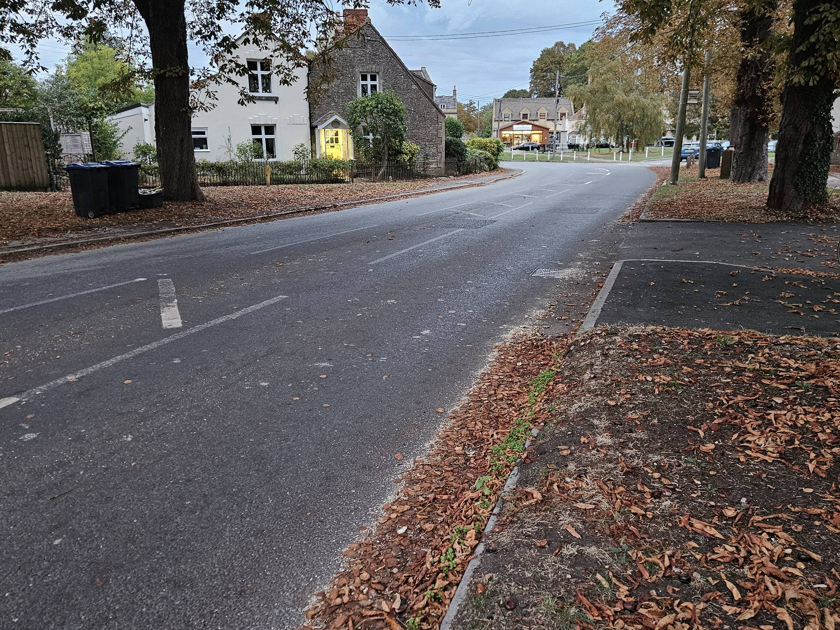
Other areas of village – please state location
The Star |  | X |  | Snapped tree at risk of falling and becoming a hazard for traffic  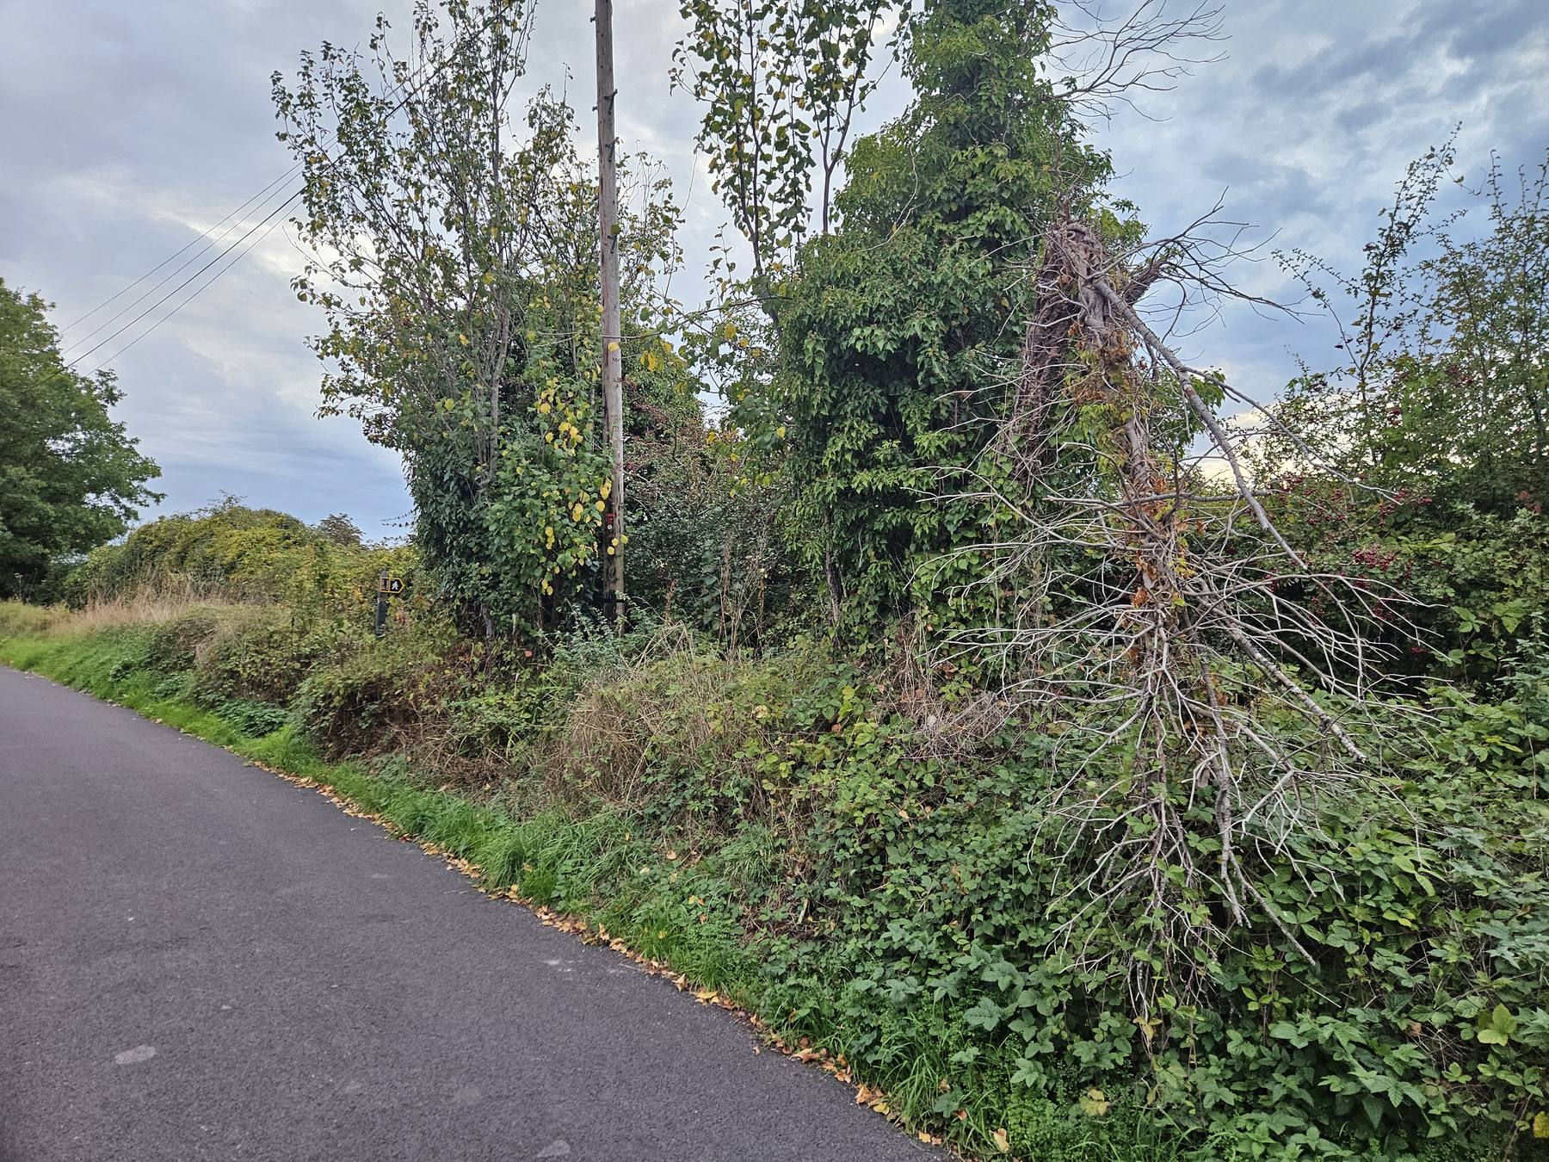  Touristic sign falling into disarray  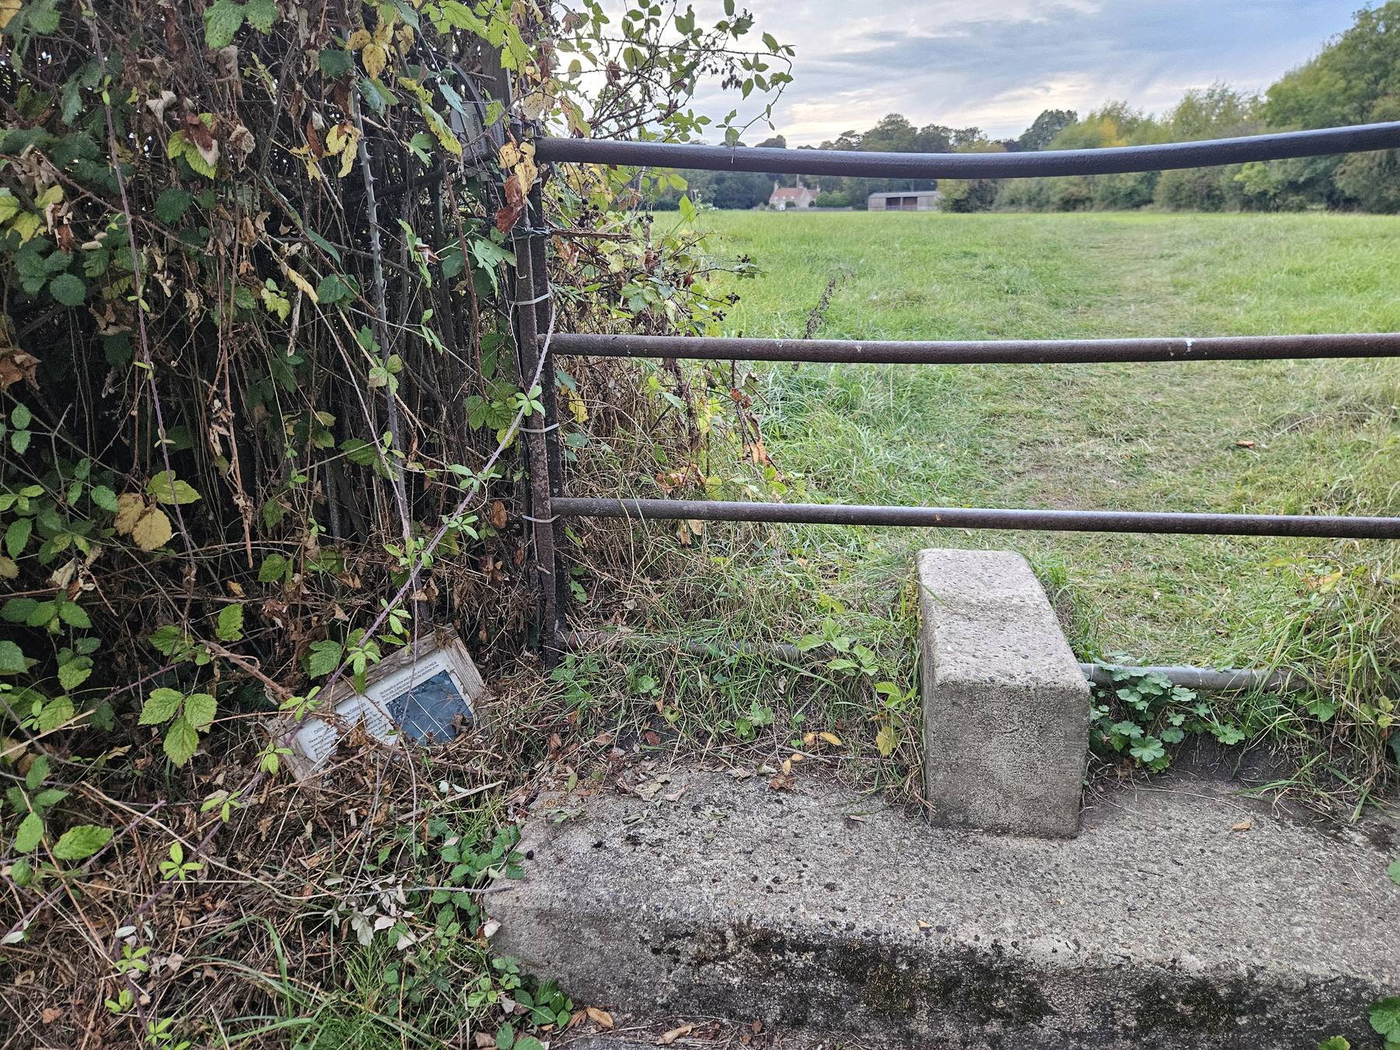
Beckerley Lane |  | X |  | Wall located in the connecting footpath between Hawcroft and Beckerley presenting damage  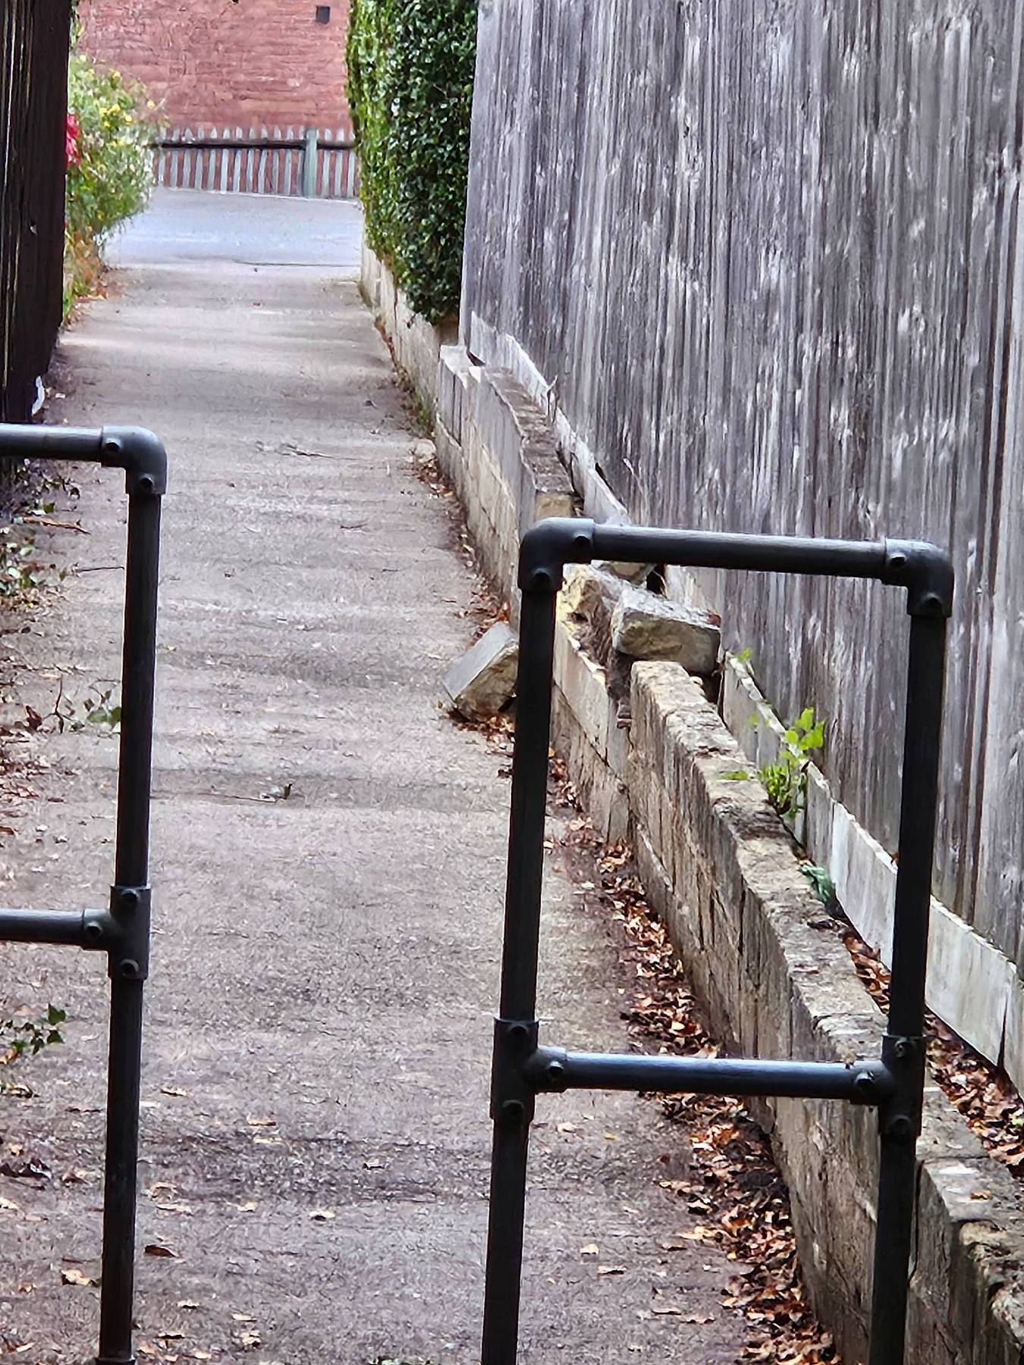
Station Road |  |  |  | Damaged pole at the end of station road  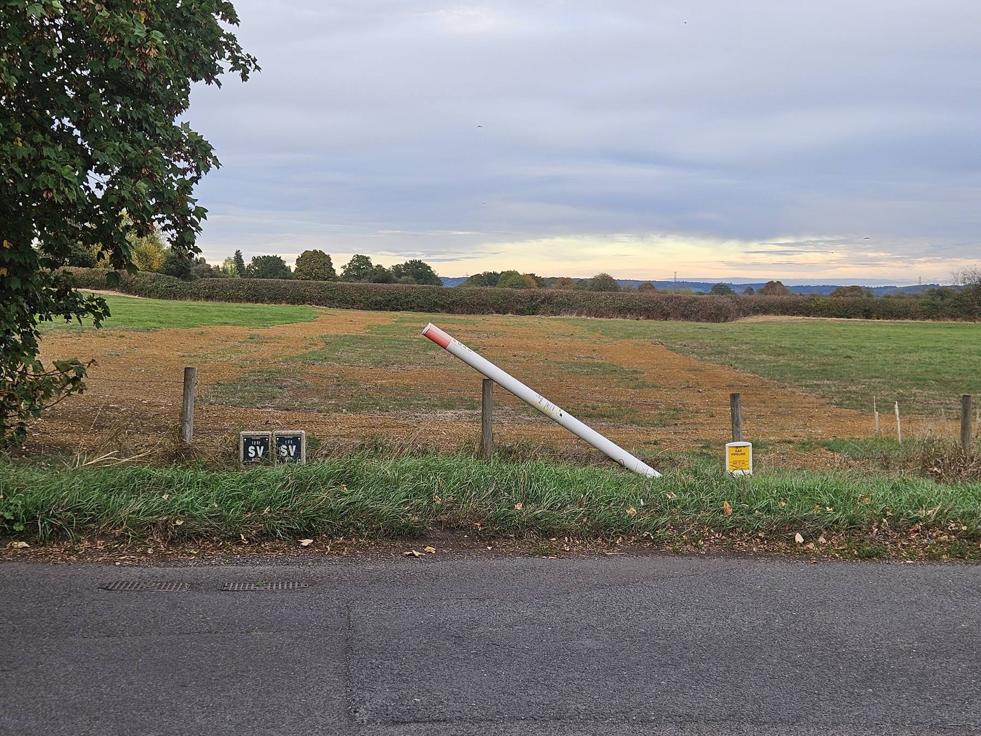
Star Ground |  | X |  | Dead trees around the green areas of Star Ground  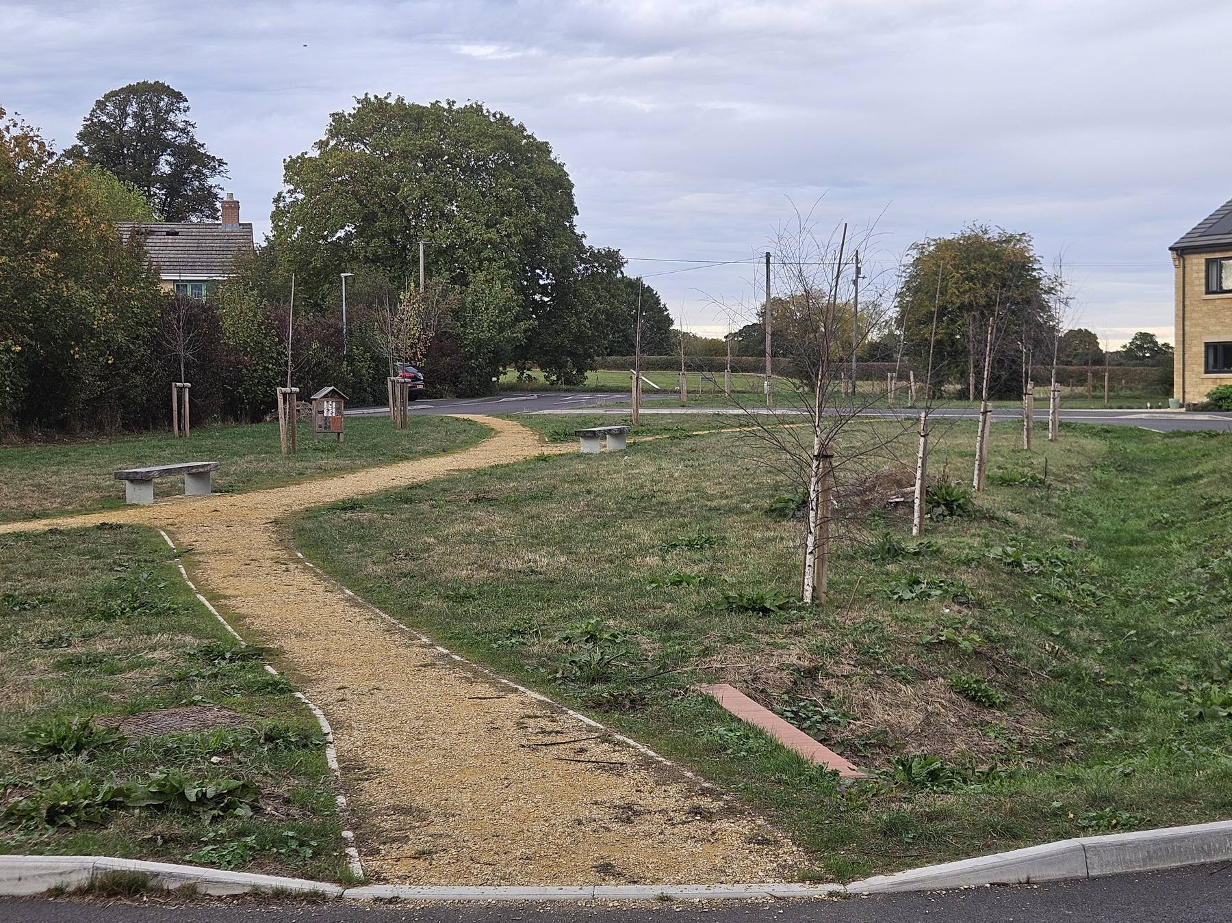  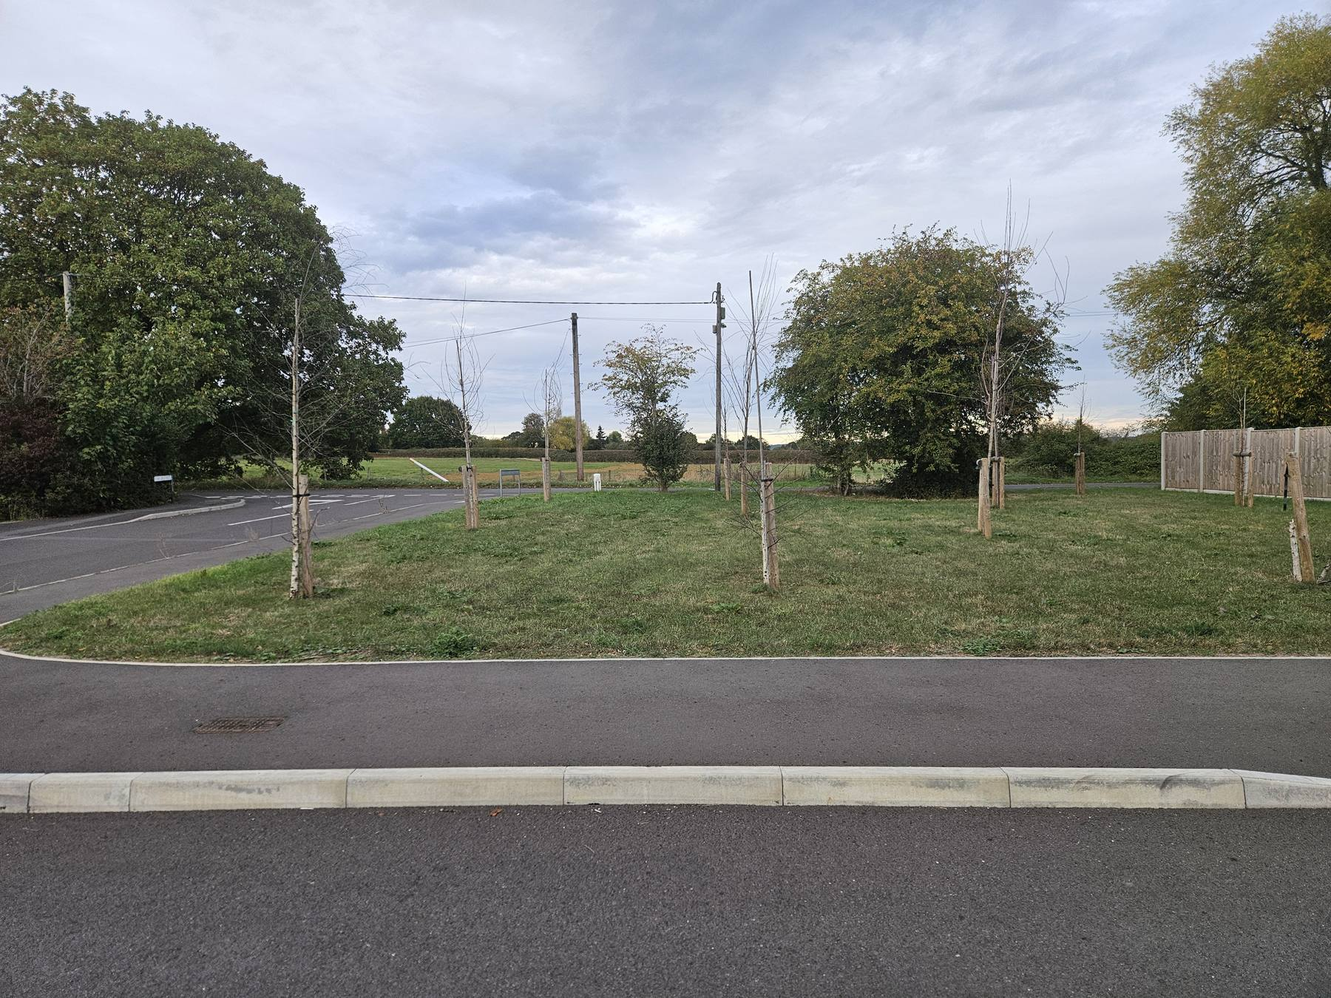

Parish Steward – tasks that can be allocated
Hand clearing and cutting of growth from drainage grips and drain gully covers
Hand clearing of blocked drainage gullies grips culverts pipes etc
Clearing storm debris from roads and footways
Pedestrian barriers preparations and painting
Cleaning and straightening of small road signs street nameplates and bollards
Securing existing small road signs verge marker posts and street name plates
Removal of limited graffiti from above
Hand cutting of grass and vegetation in visibility areas
Hand treatment of weeds
Hand clearing of growth and soil from footways
Repair of small potholes in road and on footways

Programme of suggested work/ considerations:
Month | location | Action required

