Hedge issues
Address | Issue | Action
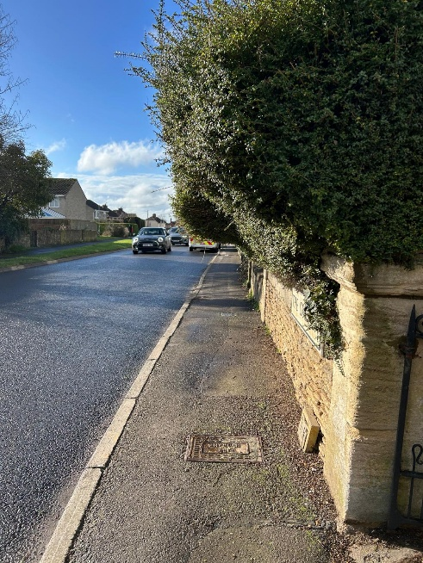 | Can’t walk the footway due to hedge overhanging.  No footway on opposite side of Melksham Road.
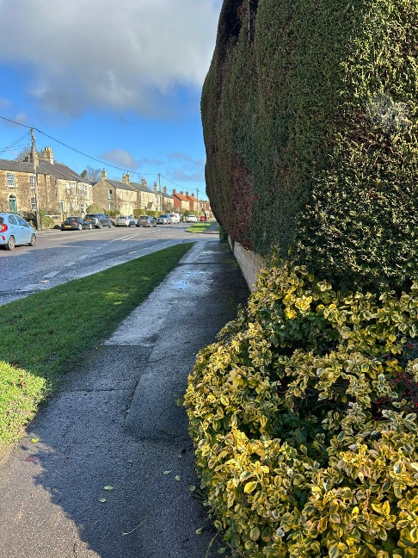 | Single width footway at parts due to trees coming out over the whole width of footway.
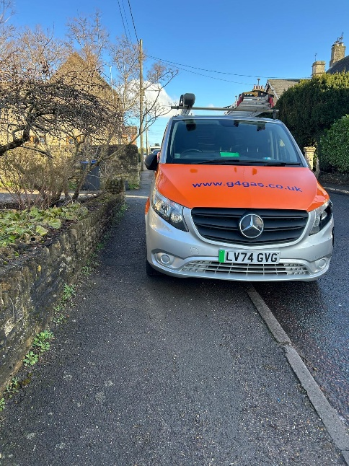 | Tree branches hanging down so anyone has to bend in half to use the footway.  When parked vehicle here impossible for most to use this footway.  (homeowner was contacted and van not working on his house at the time)
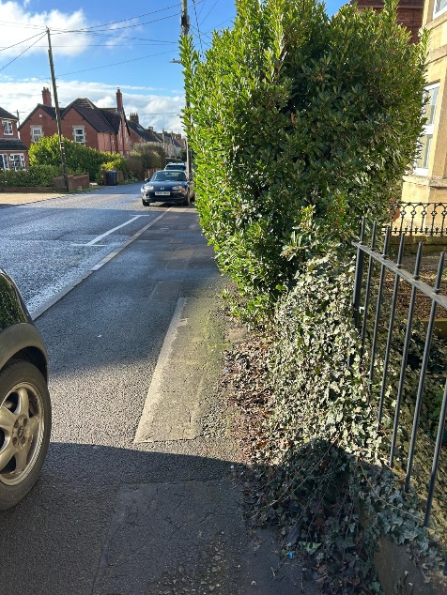 | When no car parked people can use the footway.  Hedge is encroaching on footway.
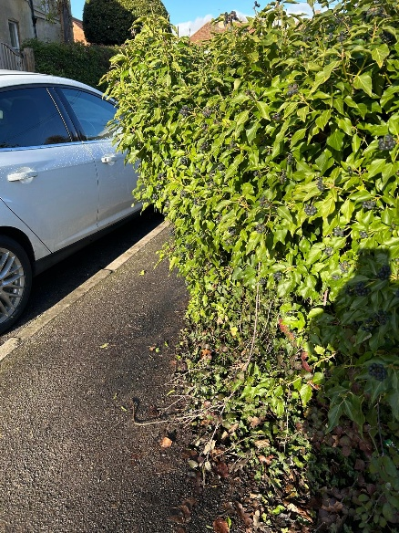 | Bush impedes anyone walking the footway and if using pushchair to access footway to and from preschool/school there are brambles and ivy entwined in the bush, down the wall and on the footway.  Noted for Parish Steward to clear footway. | 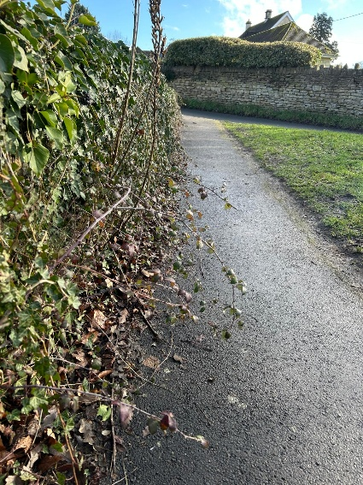
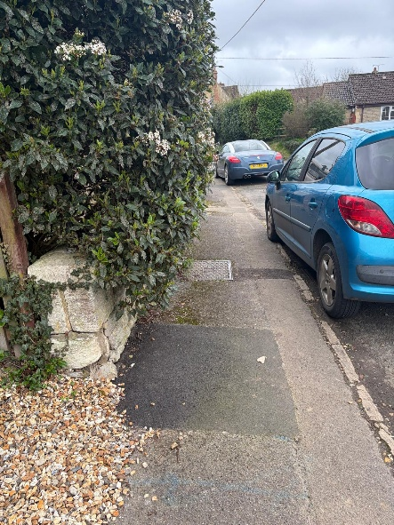 | Footway is single width due to hedge overgrowth
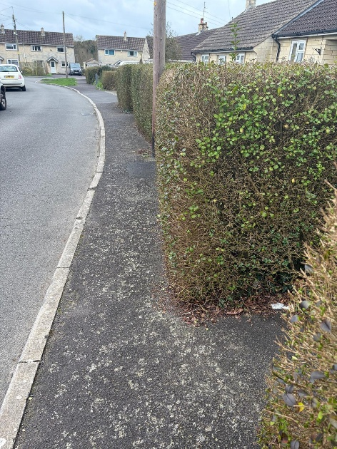 | Footway is single width due to hedge overgrowth. When step into gate entrance can visibly see extent of overgrowth on this footway.
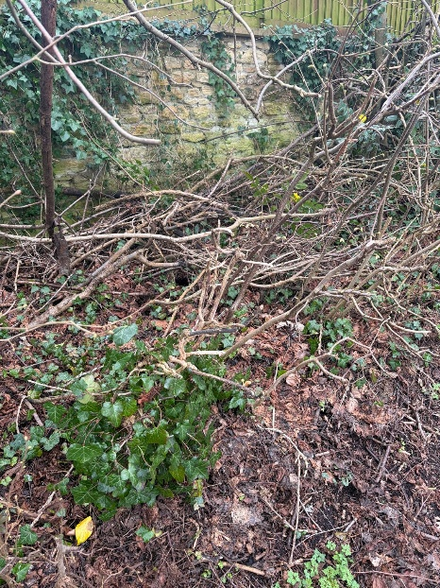 | Not sure if this is residents to clear/maintain or Parish Steward?  Lots of tree branches all over the place and look like dumped. | 