Monthly Village Inspection Report
Please try and inspect as much of the village as you can.
NOVEMBER/2025 By Cllr. Bloomfield
Parish Council responsibility
AREA | OK | X | ? | COMMENTS
Ham Green:  Grass cutting, path, litter – War Memorial | 
Other Greens:
Grass cutting, footways –
Litter -
Pavilion – general upkeep |  | x | 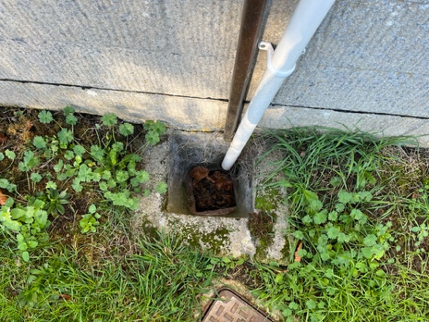 | Clear outside drains of leaves
 |  |  | 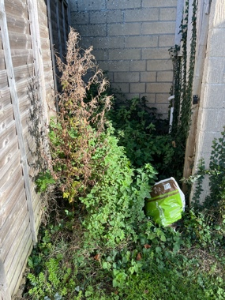 | Clear area to the side of the pavilion to keep the drain clear
Play Area litter, grass, any obvious safety issues
Recreation Ground:
Litter, grass cutting, hedges
Sports Courts: Only smaller of the 3 courts is PC owned.  Litter /weeds |  |  |  | NB: General upkeep, repair and maintenance of the 2 larger courts is responsibility of HRSC. Brook running alongside second sports court and edging Glove Factory is owned by GF and is their responsibility. We do however undertake to keep it free of litter.
Dawes Pond:  To include PC stretch of brook from Glove Factory to first “garage bridge” - |  | x | 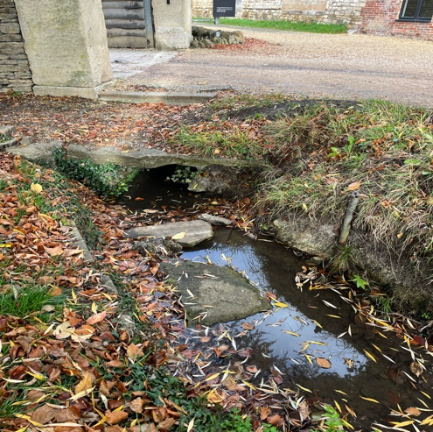 | Loose flat stones in water. These were previously part of the old footbridge and could be made good by pushing back into position and secured with mortar.
Wiltshire Council responsibility
General Litter:
Village Signs: |  | x |  |  | ‘Holt’ sign on Staverton Lane has been damaged, possibly by a vehicle and is no longer upright. Probably needs new posts.  ‘Gaston’ sign is also still missing.
The Walk |  |  |  | 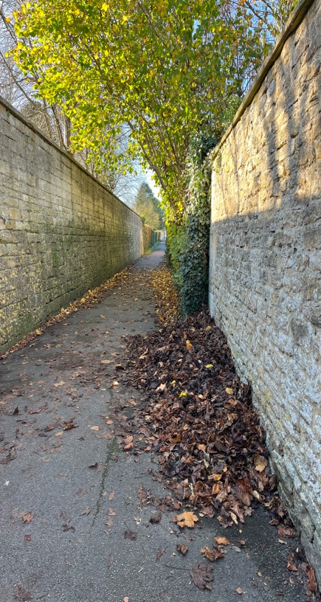 | Pile of leaves, probably work in progress.
The Midlands
Shop Area: |  |  |  |  | NB: Area of mixed responsibility to keep clear of litter – PC/WC and Shop. Flood kit is PV responsibility.
Around St Katherines Church  General -  Litter /weeds |  |  |  | 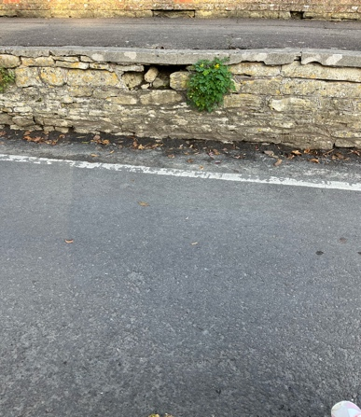 | Generally good, but damage noted to the high pavement caused by vehicles, which pushes it out of line, thereby weakening it. Stones could be replaced.
Pavements |  |  |  | 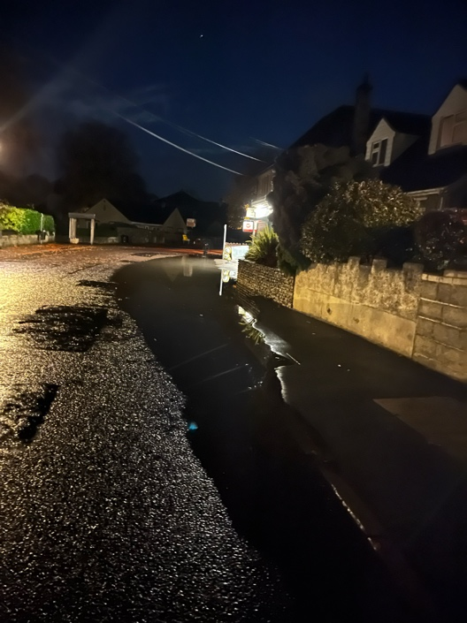 | This is on Nov 1st, about 12:30am and it illustrates how the drains cannot cope with surface water.  This had dispersed by the morning.  FYI
Other areas of village – please state location | Corner of The Midlands and The Street |  |  | 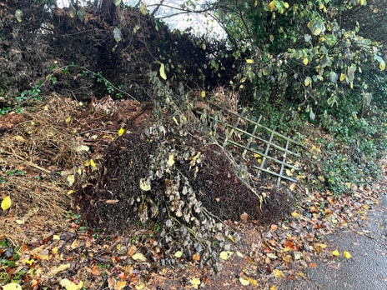 | Rubbish dumped on the verge, near the green bench.
 | Pavement from Ham Green to the TG |  |  | 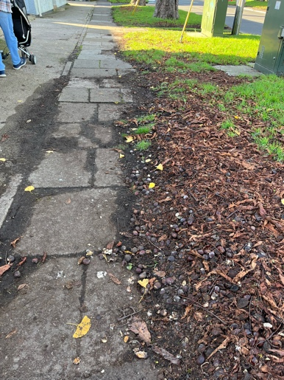 | RH side of pavement could be reclaimed if the grass was cut away and the edge redefined
 | Pavement on LH side of Bradley Lane leading to junction with Station Rd. |  |  | 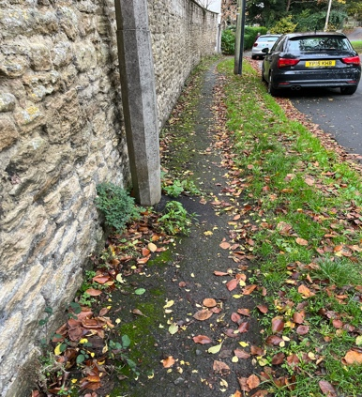 | Pavement surface is very rough and bumpy, and the grass could be cut back

Parish Steward – tasks that can be allocated
Hand clearing and cutting of growth from drainage grips and drain gully covers
Hand clearing of blocked drainage gullies grips culverts pipes etc
Clearing storm debris from roads and footways
Pedestrian barriers preparations and painting
Cleaning and straightening of small road signs street nameplates and bollards
Securing existing small road signs verge marker posts and street name plates
Removal of limited graffiti from above
Hand cutting of grass and vegetation in visibility areas
Hand treatment of weeds
Hand clearing of growth and soil from footways
Repair of small potholes in road and on footways

Programme of suggested work/ considerations:
Month | location | Action required

